APPLICATION FOR OBTAINING A ONE-DAY PERMIT FOR ESCORTED ENTRY (EE)
We apply for permission for: day/month/year | Click or tap and enter a date.
Name and surname of the person requesting EE | Click or tap here and enter your text.
Name and surname of the person who will perform the EE*. | Click or tap here and enter your text.
Zones in the SRA to which EE | Write the desired zone designation with a shortcut
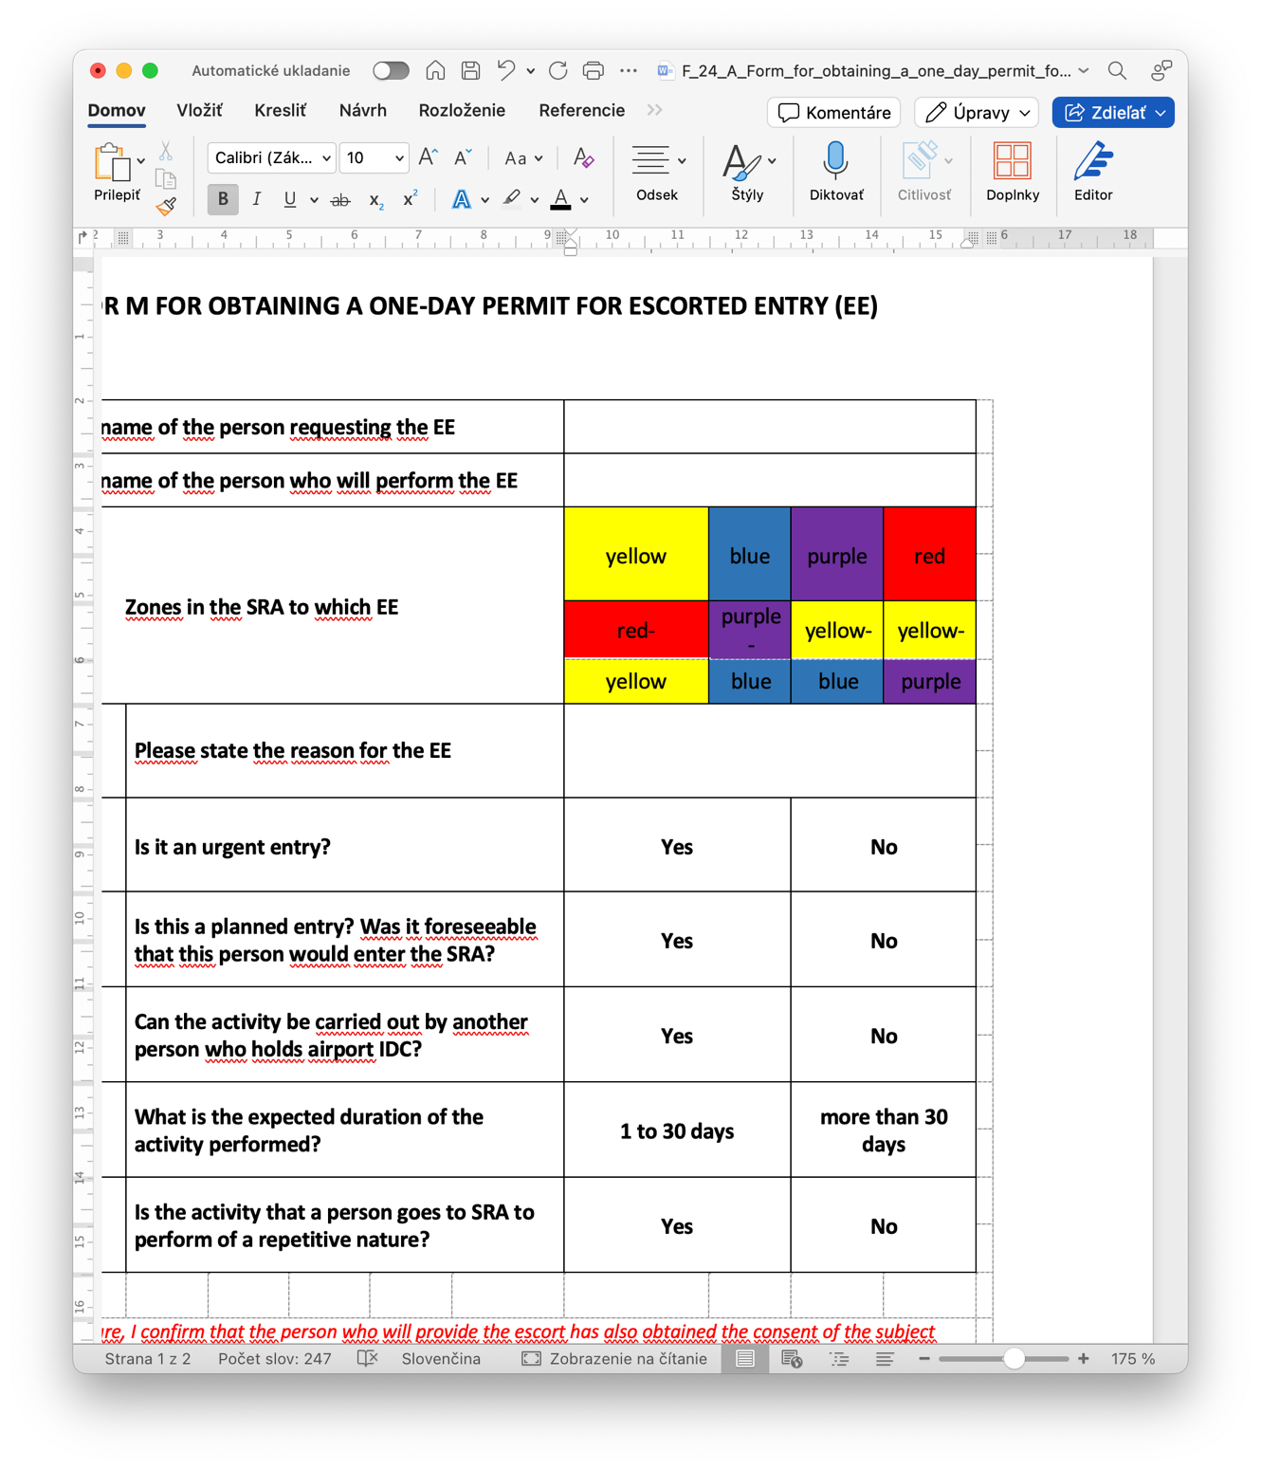 | Y ☐ | B ☐ |  | P ☐ | R ☐
 | RY ☐ | PB ☐ |  | YB ☐ | YP ☐
Please state the reason for the Guided Entry: | Click or tap here and enter your text.
Mark YES or NO | YES |  | NO
Is it an urgent entry? | ☐ |  | ☐
Is this a planned entry? Was it foreseeable that this person would enter the SRA? | ☐ |  | ☐
Can the activity be carried out by another person who holds airport IDC? | ☐ |  | ☐
Is the activity that a person goes to SRA to perform of a repetitive nature? | ☐ |  | ☐
Within 30 days Over 30 days
What is the expected duration of the activity performed? | ☐ |  | ☐
*The person who will provide escort is obliged to ensure the consent of the data subject (the person requiring an escort) for the processing of personal data specified in this form for the purpose of entering the airport security restricted area pursuant to Regulation (EU) 2016/679 of the European Parliament and of the Council on the protection of natural persons with regard to the processing of personal data and on the free movement of such data, if necessary and pursuant to Section 13 of Act No. 18/2018 Coll. on the protection of personal data and on the amendment and amendment of certain regulations.

intentionally omitted
INTENTIONALLY LEFT BLANK

